Healthy by Design New Year’s Masterclass 2017

3 Lessons for Unprecedented Health Breakthroughs in 2017

Fill in the Blanks

Lesson 1- Understand the Process of Success

Success come from moving past the ____________ _________________; going from ________________ to _________________.James 1:22 & 2:26

Key Take Aways
a.
b.
c.

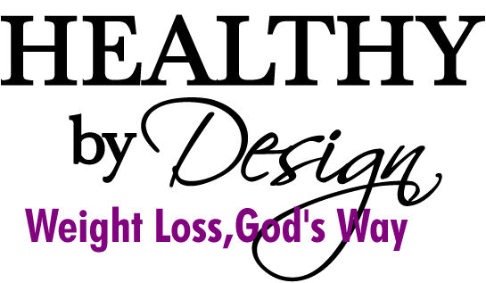
Lesson 2- Have a vision

- Good health is your ____________, not your __________. Genesis 1:27
Key Take Aways

a.
b.
c.

Lesson 3- Get to the root

Until you understand _________ you do what you do, you will _______ _________ ____________ it.

Information + ________________ = ____________________ Romans 8:5 & 12:2

Key Take Aways

a.
b.
c.

